Knowledge Based System Modelling and Simulation

Contents

**Introduction: Designing and describing my factory environment and agents** 1

• Factory layout/Environment: 1

• Agents: 2

**Robot/Agent Knowledge and Reasoning: how My agents gather knowledge** 3

**Robot/Agent Rules: The rules My agents use and follow to operate.** 4

• Traversing the dedicated path (depicted by red): 4

Queuing up 4

• Going into stations (depicted by different coloured squares) 4

Charging station 5

Packing and charging station and storage room 5

**Efficient Implementation: Implementation and report on my solution in Net Logo.** 5

Description of how the simulation runs in net logo. 5

Use of experiments to help assess the efficiency of the stimulation. 6

Experiment 1: Robots 6

Experiment 2: Energy 7

Experiment 3: Robots part 2 7

**Conclusion/Evaluation: Evaluation of the efficiency and utility of the factory using plots.** 8

References 9

# **Introduction: Designing and describing my factory environment and agents**

## Factory layout/Environment:

The factory layout of my choice is a four-grid layout in which there is at least one of every required machinery in half of the grid. As shown in the diagram Figure 1. The environment of this factory is nothing to fancy, it contains a charging point depicted by the white coloured square which will recharge the robot(agents) for an energy recharge of five. When the agents depicted by coloured arrows receive an order after going to the storage room depicted by the colour green, they will then traverse to the packing station depicted by the colour pink, here is where the orders are packaged. possible limitations that will be present is that only one order can be processed and thereby that means only one robot may be present to package an order so any other agents will be queued and must wait or will traverse to a different packaging station that is empty. Once the order has been packaged it is then taken to the dispatch station depicted by the colour blue which is there the orders go to after being packaged to be sent off. Finally, the plan for this is for the factory to be able to run on its own, receiving more orders. The time is measures in ticks in this factory.

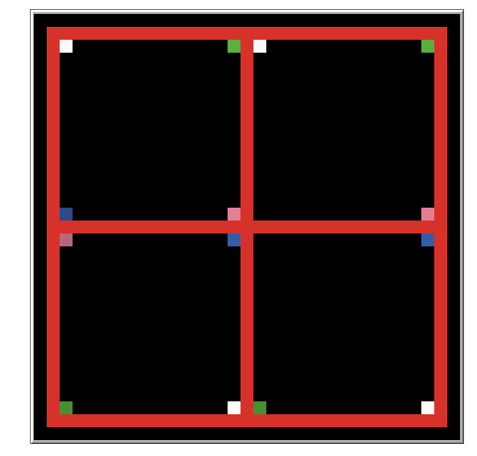 [ Figure 1]

## Agents:

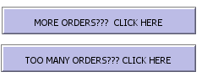As briefly described the factory will consist of five main agents, that we will now go into further details and any other useful information. So as previously mentioned, the patch that is white represents the charging station in which the robot that is an agent can go to and recharge, the goal of this agent is to be a reactive agent and react with the other agents (the robot) and help recharge the battery capacity developed into the agent. This is essentially an important agent as it ensures other agents can progress with their goals and objectives. The other agents present are not as reactive as the charging station but of course have its own goals, for example the packaging station and dispatch station won’t be as reactive with the robot as the charging station was but will be aiding the robot in completing its goal. The final main agent will of course be the robot that will have many goals and objectives and rules to follow. The robot depicted by the arrows will be reacting with all the elements/agents that will be in the factory with its primary goal to just package orders received and dispatch them. To help show the robots completing an order they had been programmed to change colours upon leaving stations. When a robot is yellow, they only go into charging stations or a storage room and when they leave, the robot changes its colour to cyan to depict that the robot has received the items for the order. When they then go to the packing station and leave the colour changes from cyan to black to depict that the order has been packaged and finally when the robot goes to and leaves the dispatch station their colour turns from black to the original colour of yellow, this is to show that the order is no longer with the robot and has been sent away. This is all done by the stimulation without human intervention and there are only two buttons (besides the setup and go button) in which an observer (user) can use, these being the increase more orders and decrease the number of orders.

Figure 2

So, to Summarise the agents used in the factory using the Peas, there is the following:

* The robot – will have a performance measure check in if it has not received any orders or picked any from the storage it will temporarily fall asleep out of the way of other agents. To help save energy and ensure it doesn’t get in the way of other agents such as occupying charge points for robots that are working. It will also be able to analyse information gained and use it to its advantage such as most efficient way to complete an order. Its environment will simply be the layout of the factory in which it will have four ways to possibly traverse allowing multiple paths for multiple agents. the Actuators involved in this robot will be hydraulic actuators that enable the robot to move, it receives signals from the robot control system and executes the corresponding movement and in this case, this could be such as coordinating the movement of a robotic arm to aid in picking and packing orders (ROBOTNIK, 2023). Finally, the sensors present in this agent could be the following such as cameras and ultrasonic sensors to act as their eyes to help the robots move around and identify locations of other agents and its environment and even help package orders. Touch sensors and even motion sensors (for example proximity or distance sensor) to enable the agents to sense movement of other agents present to prevent collisions.
* Charging station – there will be test regularly done on this to regulate the performance of this machinery such as the rate it recharges the robot is to the expected standard and to just ensure it is not faulty. possible actuators could be an electric rod style actuator which is used to help with movement and strong grasp and in this case, it would help clamp the agents to the charging station to ensure no accidental departure until robot is charged. Finally, the sensors involved in this may be pressure sensors so the charging station can feel when the robots are in proximity and voltage sensors which measure the voltage such as detecting high or low voltages and then from this with the information received, they can decide whether more voltage is needed and provide.
* Packing and dispatch stations – there will be little need of performance measure as this is not as reactive as the robot or the charging station, this is where the agent comes to complete an order. However, any measurements to ensure that the is up to standard for the robot could be things as making sure orders are compiled in a neat and efficient way that make it easier for a robot to travel and consume less energy or making it easy to pack and/or dispatch orders so the robot can focus on other orders. Sensors present would also be a proximity sensor to enable the stationary to feel when a robot is near and prepare to receive an order from the agent.

# **Robot/Agent Knowledge and Reasoning: how My agents gather knowledge**

There are states in which all agents will be in, some more than others this is to help the agents gather information and reactive with other agents. The main one is the robot with many states. Its first state is movement, the robot will be free to move alone the path depicted by the red line as shown in figure 1, All agents will move along the path in a clockwise way to help prevent head on collisions, but they still have four pathways they can take. If the robot isn’t carrying anything then it can move along the path until it reaches a new station and can either recharge or start to pick an order from the storage room, the robot will only be able to carry one item both while moving but also just when packing it. But if the robot is carrying something then it can move to other stations to recharge but it cannot proceed to and stay at a packing order station or a storage room until the current order has been dropped off at the dispatch station. Another state the robot will be in is a state where it isn’t moving. This can be from multiple things such as recharging or packing and dispatching orders or just even queuing behind other robots to do them, it will also take in the case of a robot moving ahead of it and if it will not be able to overtake it the robot will queue up until there is space available to move. The robot will be able to do all this based of all the info gathered and analysed through its sensors already mentioned in the introduction for example with its motion sensor if it detects that there’s something blocking its way it will then procced to queue and stay until there’s space available for it to move. Or with its actuators it can pack orders and carry them while also moving.

As already briefly mentioned there are only two reactive agents in this factor one being the robot and its states described above but the other is the charging station. There won’t be as many states as the robot, but the charging station will either be in a state of waiting to react with the robot or will be reacting with the robot by charging.

# **Robot/Agent Rules: The rules My agents use and follow to operate.**

The rule of the agent is designed so that the robot will always move clockwise and will halt if there is another turtle in front of this, it has many rules it must follow such as:

## Traversing the dedicated path (depicted by red):

Mapping a path for the robot to traverse by simply getting the coordinates of one patch on one end and doing the same for the other end, by doing this in each corner a square path is generated which when the robot is told to traverse the red coloured patch it will do only that. For example, | **ask turtle if y = 15 and x < 15 FD 1** |– this simply states that for while the robot is on the coordinate y 15 and is still on the x co-ordinate between 1 and 14 it will move forward by one. By doing this for multiple co-ordinates and setting the heading to be different the robot follows this rule and can operate and travel on the allowed path.

### Queuing up

The robots will queue up behind one another when traversing the path, this is due to the code asking then if there is not any turtles on the patch ahead.



Doing this enables us to make the robots act in a real-world manner where they can’t run over each other.

## Going into stations (depicted by different coloured squares)

Upon following the mapped route, the agent has choices when in proximity of a station, using the same rule for the path when asking the turtle if the coordinates of itself is currently next to a station it can set a heading and move forward and continue like that. For example | **ask turtle if y = 15 and x = -5 set heading 180 FD 1 set heading 0** | – this bit of code would ask the turtle that if the coordinates of the patch it was occupying was the same as the one being checked its following actions would be to turn its angle downwards , progress by one space , and turn its angle back upwards to return back to the path. Doing this for all stations allowing the robot to move into them when possible and when the robot does it changes colour to show an order being processed.

### Charging station

Carrying on once the robot (agent) enters any station it’s up to the other agents (stations) to do their roles and objective. The charging station is of course where the robots will be charged so they can do their own jobs. The rules that the charging station follow are simply that if the robot is on its patch, then it will recharge the robot for an energy of 5 every tick, the code of this is small and resembles the following | **ask turtle if patch = white set energy + 5** | **–** this states that if the turtle is on the white patch then it will gain a charge of energy of 5 and the next bit of code **| if patch = white and energy > X set heading 0 FD 1 set heading 90 |** is for both agents to follow in that when the robot has energy over x amount the charging station will no longer charge the robot and this means the robot should leave the station leaving it free for other agents.

### Packing and charging station and storage room

As these are not as reactive as the charging station there is less rules they need to follow. Simply the robot (agent) can go into all of these. However, there is a few rules the robot follows when cooperating with these other robots such as, if the robot picks an order, he cannot pick up any more orders from any other storage room and the next step is that it must go to a packing station before finally going to the dispatch station. In other words, the robot must follow the simple rule of pick one order, package the order and dispatch the same order before proceeding to pick up another. Another rule is that only one robot can be in each station, so the robots must queue.

# **Efficient Implementation: Implementation and report on my solution in Net Logo.**

Finally, after describing what all the agents are and their respective roles its useful to explain and demonstrate how they would run in the simulation in net logo, and this is by doing experiments.

## Description of how the simulation runs in net logo.

Referring to the first three chapters we now know the expected roles and objectives of each of the agents. To show the idea of this created factory and its environments a stimulation was created in the app ‘Net Logo ‘. How this stimulation runs are that its predetermined by 4 robots (of course this can be changed to have more or less) upon pressing the set-up button the factory will come into place along with its robots, you will see there is ten orders to begin with. when the Go button is clicked it does the following things

1. It sets of the robots to move around that factory allowing them to do the things they were coded for such as going to stations to charge or pack orders.
2. Every 15 seconds or so a random number of orders ranged between 1-15 is received adding to the total counter.
3. When the total orders received is more than 15, three additional robots are created to aid in completing orders – this is to reduce the amount of pile up in orders. And when the orders reduce to below 15 it finds all additional turtles with no item (yellow) and gets rid of them.

By this, the stimulation is now able to show and depict how an overview of the robot would work with other agents.

## Use of experiments to help assess the efficiency of the stimulation.

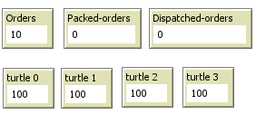The general idea for these experiments is that they are all tested with the different variable such as a change in number of robots or change in number of orders received and completed. The only bias in this experiment is that with in the four options they can randomly choose from some paths are shorter than others. However, they are once again done randomly and not picked by human intervention. With the use of monitors we can measure whatever variable we are experimenting against.

Figure 3

### Experiment 1: Robots

In this experiment we tested the efficiency of having 5 robots to complete the initial ten orders before more is received , this essentially means the robot has 15 seconds to succeed in this, the reason why this was tested was because we wanted to measure and check that the robots idleness and make sure that the layout of the factory was designed so that in almost every area the robot was being put to use. (Keep in mind that as the go button was pressed orders had instantly been added but we still only measured how effective the robots were before additional orders had been received referring to figure 3 we used the monitors that have orders in its name.



Upon three tries the results were as following:

First try -> unsuccessful, 8 orders had been packed and 8 dispatched.

Second try -> unsuccessful 9 orders had been packed and only 8 had been dispatched before additional orders had come in.

Third try -> unsuccessful, Results yielded the same output as the second try.

There are many other factors that take place into this such as the energy in a robot and whether it needs to waste time recharging due to the path it takes or even just the speed of the robot. But overall, despite all three tries being unsuccessful it can be argued that the robots are able to retrieve, package and dispatch orders in a reasonable time so for future experiments I would do a few with a smaller time gap such as 10 seconds but also a few with a larger time hap such as 20 or 30 seconds. So, on average the recommended number of robots to have could be around 4 or 5.

### Experiment 2: Energy

This experiment is like the first experiment but instead of testing the robot’s capability to complete an order, we are simply testing the amount of energy dispersed when a robot travels around an available path and does the full circuit. In other words, all these experiments are conducted with the finish line being the starting line (At fd -15, fd -15) and with no other robots on the field. Referring once again to figure three the monitors showing energy were used to help us derive these results.

Top left quadrat

Loop was successfully completed while completing an order and the consumption of energy was around 60 in total meaning the remainder energy was around **40** before reaching the charge station.

Top right quadrat

loop successful completed while completing an order and the total remaining energy was **24** when starting from the middle but when starting from original place the remaining energy was **9**. This was expected as for the robot to complete this circuit it must take the longest path available with no recharging stations close by. Possible adaptations may be added to this route by adding an extra charging station.

bottom left quadrat

First half journey around 55 energies had been consumed before reaching next charging station and order has been completed, and then the second half journey energy consumption was around 54 and order had been completed. (Recorded with the distance between the top left recharge station and the bottom left and measures the energy lost both times).

Bottom right quadrat

This experiment took a lot longer and is not as valid as the others, but the first half journey took around 65 energy which means there was only around 30 energies before it reached the next charging station, and this was estimated to be the same for the seconds half journey before fully completing the whole factory circuit.

After considering all these experiments we concluded that the most effective and less energy consuming path is of course the top left quadrat but in second place is the bottom left quadrat. of course, this is all because the starting position in this factory s on the left side so if it was in the middle all paths would be equally useful.

### Experiment 3: Robots part 2

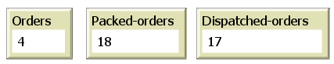Final small thing to test was how many robots could we increase to before we had a slump which meant how many robots would be too much when orders were being completed or getting in each other’s way. This experiment is one that will always be able to be tested and changed as we could increase all the other agents to counteract this problem but leaving the way our factory is we increased the robots. This experiment was done by letting the stimulation run until the ticks reached was 1000 (while being normal speed) and if the orders were more than zero it was considered a successful experiment.

First try (5 robots) -> success, 4 orders left.

Second try (10 robots) -> unsuccess, - 14 orders

Third try (15 robots) -> unsuccess, - 43 orders.

This experiment is hard to consider a real one as mentioned every other factor can be changed to increase or decreases. Such as the time interval in which orders are received, how many orders are received before the deadline and how many storage rooms there are. But to finalize this experiment the most efficient robots we should have on this factory layout is around between 5-10 robots as this is the most efficient way to ensure the robots are being used in every way and completing orders but also not roaming around wasting time, energy and space.

# **Conclusion/Evaluation: Evaluation of the efficiency and utility of the factory using plots.**

In conclusion with the factory and agents used we can come to the agreement that this design is quite suitable and efficient for the robots to be able to complete orders in a quite quick and fashionable way. As proven by experiments

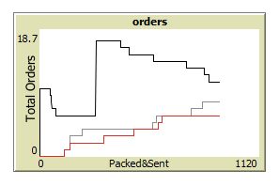

This is one of the plots present in my stimulation which just shows that the orders packaged and dispatched are at a steady incline working almost together which suggests that orders won’t get packaged and not be dispatched for way too long. And the total order increases a significant amount after an interval as expected (see massive jump spike) before gradually decreasing.

Figure 5

This is what I expected as when the factory runs it is meant to receive new orders every now and then and the robots can complete the orders.

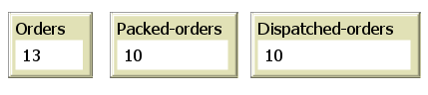 As shown the orders has been regenerated back to more than the initial orders and there’s also been 10 orders dispatched.

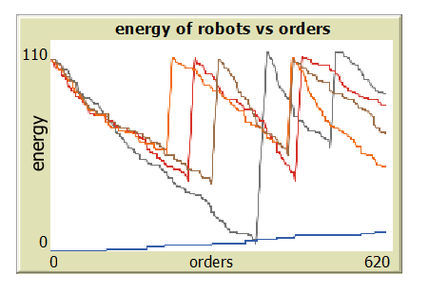

The second plot also shows the success in the robots can recharge while also completing the orders.

Figure 6

Figure 7

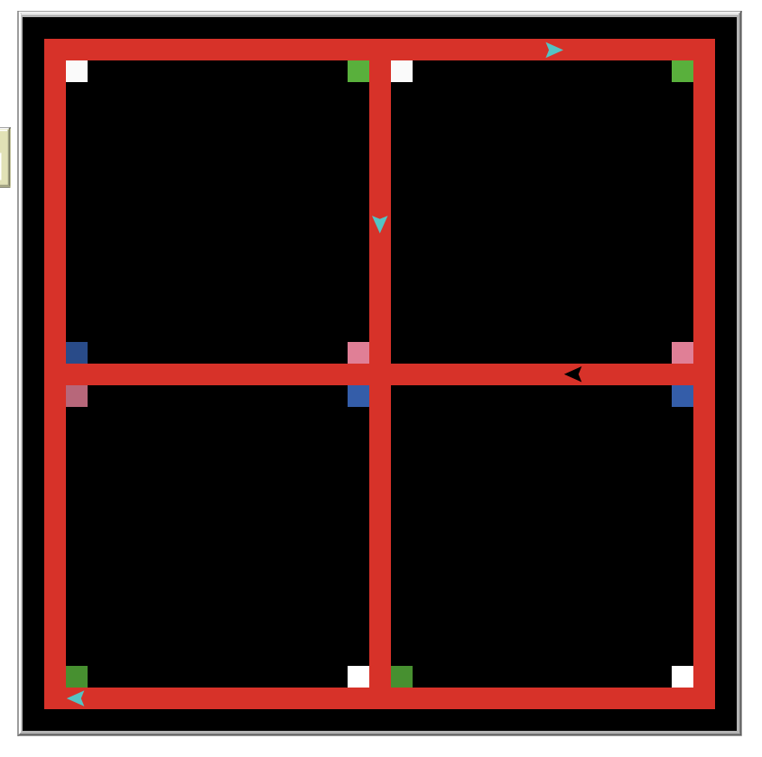

Final thing to mention is that our initial plan of the robots is a success as they can move around all pathways at a random choice while also queuing up.

If we were to want to improve this factory furthermore there are small things that could be done such as just increasing the number of stations by a marginally amount and number of orders received. But even with the way the factory is designed this shows on a small scale how effective it would be, so for it to be used in large factory’s simply having more robots and more stations (for example three times the stations next to each other) would help.

Another thing that could have been done to make the robots more efficient is have the robots learn over time which path is the quickest and most efficient way to progress and complete an order. Alternative implementations I would have used would be different types of robots in the agents such as drones that could fly over all robots and completing orders alongside. And emergency stations along the side for when a robot is nearing to low energy.

Overall, this stimulation was a success as everything planned for the factory to be able to do was manageable and completed. The stimulation matches the initial plan of the factory and its agents. The process in which we did this was first making the factory and the agents and making sure the agents were comfortable enough moving around the whole track, the next process was adding our stations and programming them to react with the agents and observers such showing change in colour to depict the changes. Then additional things such as support robots were introduced to combat pile up of orders taking in the fact of a real time factory and trying to get as many orders completed as possible.

# References

ROBOTNIK. (2023, 04 13). *ROBOTNIK*. Retrieved from ROBOTNIK: https://robotnik.eu/types-of-sensors-used-in-mobile-robots/